Judging Congress at WACFL
What you need
- Congress is judged online through Tabroom.com. You need a Tabroom account (free) which your coach can help you set up. Please bring a WIFI enabled device for judging. A laptop or tablet is preferred over a phone since you will need to type in comments on the ballot.
- You will typically not judge all of the sessions, but you must stay for the whole day because you will be notified of judging right before each round. You are welcome to bring reading, work, etc., to do in the judges’ lounge when you are not judging.

Thank you for judging for the WACFL. The tournament strives to assign judges with no conflicts in the chamber, but we sometimes have to juggle a bit to make it happen. Judges may be used for one or multiple sessions, and occasionally we have a judge present we do not assign at all. This does not mean you are not valued, only that there were a lot of students from your school competing across several chambers. At no time should you judge your own student, and rarely will you judge students from your school unless specifically advised to do so by the tournament director.
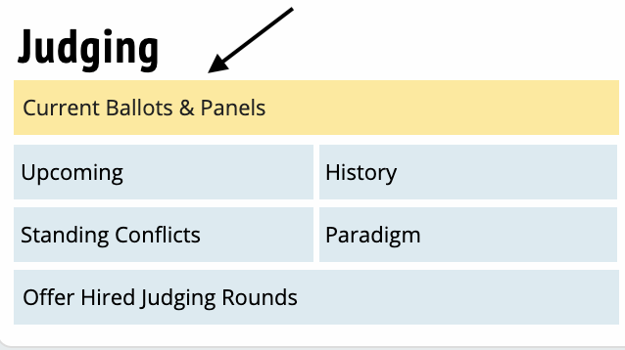
Assignments
You will receive your judging assignment(s) from Tabroom.com shortly before each session. Please check your Tabroom account before each session to see if you have an assignment. If you are not assigned, please stay in the judges’ lounge in case the tournament director needs to make judge substitutions. Please do not go watch a chamber as you may be assigned to judge there later in the day.

Judging
Please arrive at your assigned chamber 10-15 minutes before the session starts. Go into your Tabroom account and click START on your assignment. This takes you to your ballot, and lets the tournament staff know you are present in the room. Please silence your cell phone.

As the session begins, there will be a bit of chamber business that you can ignore such as the administration of the oath of office and the election of a presiding officer.
Ballots
When the Presiding Officer (PO) calls up the first speaker, that student will come to the front of the room and announce their name. If you didn’t hear it, raise your hand and ask for the name. Your Tabroom screen has a scrolling picklist for you to choose that student’s name, which will give you a ballot for that speech. Each and every speech gets its own ballot.

The ballot has space for you to fill in the legislation name (you can abbreviate – A Bill to Ensure a Basic Income for All Americans could be just “basic income”. Please also note on the ballot if the student is speaking in the AFF(affirmative) or NEG(negation).

As the speaker is giving their speech, please jot down comments on the ballot, what they did well, and what could be improved. Areas to consider in evaluating the speech:
- Delivery: does the speaker manifest poise, style, coherency, and a seriousness of purpose in presenting the speech?
- Originality of thought: does the speech advance debate or merely rehash old points? Is there a new twist or angle to the argument? Does the speaker take into account arguments made by previous speakers and offer refutations?
- Organization and unity: does the speech ramble or does it develop? Does the speech move from point to point in an orderly way? Are rhetoric and impact statements used to enhance the arguments?
- Evidence and logical basis for statements: Does the speaker provide references to their sources? Are those sources credible?
- Overall impact and impression
- Refutation: Refutation is not a required component of a speech, but is recognized as an enhancement to a speech. A speaker has listened to previous speakers, and addressed a point (often by naming the speaker) specifically, refuting the evidence or validity of the point. A good refutation is not just stating that a speaker’s point is incorrect, but explaining why it is incorrect and supporting that with evidence citation(s).
- Rhetoric and Impact: These are components typically seen in more advanced speakers. They use some background information to lead you into their speech, and talk about the impact of passing or failing the bill. This can make a speech more persuasive and effective. A little is a great thing, but it should not replace valid points with complete analysis supported by evidence.

Please set aside your own beliefs on the topic. You may disagree vehemently with a student’s speech, but please evaluate the speech on the criteria above.

Please remember these are high school students and keep comments kind and actionable. For example, I had trouble following your argument because the speech was delivered so quickly, or your arguments made sense, but would carry much more weight if you cited your evidence.

Please do not comment on student’s attire, hair, accent, or other comments not related to the speech itself.

After you have made a few comments, you need to score the speech on a 1-6 scale, where 1 is the lowest score and 6 is the highest score.
6 is an excellent speech, advancing the arguments and supported with evidence citations.
5 is a very good speech with one or two areas for improvement.
4 is a good speech with quite a few areas for improvement.
3 is a speech that was an honest attempt by the student but needs substantial improvement.
1 and 2 - Please reserve scores of 1 and 2 for speeches that were on the wrong bill, on the wrong side (e.g., an AFF when they were recognized for a NEG speech), extremely short (e.g., 30 seconds) or offensive in some way.

These scores are used for NSDA points and to help the student/coach know what you thought of the speech. They do not determine who wins the tournament. If you are on the fence, giving a score of 3 or 4, be generous
Ranking
At the end of the session, you will need to RANK the top 8 speakers. These ranks, combined with the others judges’ ranks from all of the sessions, determines the tournament winners.
- Go to the Ranking tab in your ballot.
- Place a 1 next to the BEST speaker for the session, a 2 for the second best, and so on down to the 8th best speaker.
- No half-points and no ties are allowed. You may consider the students speeches, questions, answers to questions, and activity in the chamber in this ranking.
- Please consider the presiding officer (PO) when ranking. Serving as the PO is a critical role to the chamber. Did the PO run a fast and fair chamber? Did they maintain order in the chamber, or were there times that it seemed out of control? Did they keep track of who had spoken correctly or were they frequently corrected by the Parliamentarian or the chamber? You are not required to rank the PO, but please do take them into consideration.
Please do not confer with the other judge in the room on your speech scores or ranks. Your scores can and will differ from the other judge as we all hear the speeches differently and value different aspects of the speakers performance.

When finished with your ranks, press SUBMIT. Tabroom will now display your ranks for a final review. If everything is as you intended, press SUBMIT. Once you do this, your ranks are final and can only be revised if you go to the tournament staff. Once you have submitted your ranks, you are done with this session and may return to the judges’ lounge.

Note that your scores/ranks are final, but you may continue to finish your comments until the awards ceremony at the end of the day. Some judges will make very short comments during the session, e.g., The Daily Show-Bad, and then go back and expand that later to The Daily Show is not a credible source for evidence as it airs on the Comedy Central network.
Please do not give students any verbal feedback, either at the end of the session or throughout the day. This is important for the fairness of the tournament! The students and their coaches will receive their ballots with your comments after the awards ceremony.
Need Help?
The parliamentarian is the adult in the room who can help. If you are having connectivity problems, they will notify the tournament staff. If you urgently need a break, raise your hand and they will stop the session for you. If you are having trouble hearing and need to move closer, or need to move to a power outlet, they can facilitate that. The parliamentarian cannot tell you how to rank the students, but they can assist with the technical aspects of submitting your ranks.

