2024-2025 Policy Resolution:
Resolved: The United States federal government should significantly strengthen its protection of domestic intellectual property rights in copyrights, patents, and/or trademarks.
Tips for Judging Policy Debate  - Be an objective observer - Your job is to objectively evaluate the arguments presented to you. Do NOT let your personal opinion or stance on an issue affect the way you judge a round.  - Evaluate the argument, not the style - The focus of a policy debate is the logic presented by debaters. No matter how great the presentation is, you should always vote based on the strengths of arguments.  - Flow (take notes) - Use abbreviations and shorthand. To evaluate the arguments presented in the debate, you need to have a detailed note of what was stated throughout the round. You should use a new sheet of paper for each argument.  - Be supportive of novices who are confused - It is okay to remind them of speech times and order as well as other technical aspects of the round. It is NOT okay for you to help them with their speeches in any way.  - An argument that goes unanswered is considered true - Arguments that are not answered are considered “dropped” or “conceded.” If an argument is conceded and the opponent “extends” or explains it throughout the round, the argument must be evaluated, and no matter how ridiculous, it must be considered true.  Note: That does NOT mean the team automatically loses, but when you are deciding at the end of the round, you must give conceded arguments significant weight.  - Arguments are only valid if they are extended throughout the round - In debate, arguments should be “extended,” or re-explained, and answered throughout the debate round. An argument that is made in the first speech, then ignored until the last speech should not be considered. Similarly, an argument made at the end of the debate without being made in the earlier speeches is also not valid.  - Evaluate impacts at the end of the debate - Before you vote, you need to piece all the arguments together. Evaluate the impacts from each team and decide which side explained the impacts of their arguments best. What would the world look like if the policy passed or was rejected? Whichever team creates a better world gets your vote.  - Make sure debaters do not exceed their time limits - While you may feel bad cutting them off, please do not let the debaters speak longer than they are supposed to. This also applies to prep time.  - At the end of the round, provide positive, constructive feedback for the debaters - Whether students are new to the activity or have a wealth of experience there is always room for improvement, but also ballots should be encouraging. A general rule is to pair each constructive criticism with a positive comment.  - Do not give verbal feedback or tell the debaters who won - they will get your feedback and decision at the end of the tournament.  - Know that your evaluation of the round is always correct - The debater’s job is to convince you that their side is correct. No matter how well they think they explained an argument, if they do not logically prove it to you, they didn’t do their job correctly. Be conscientious, but don’t worry about making the “wrong” decision because there is no such thing.  - Have fun - You are helping students compete in an activity they give up their weekends in which to participate. Have fun with the students and enjoy the difference you are making in their lives. | Speech Times  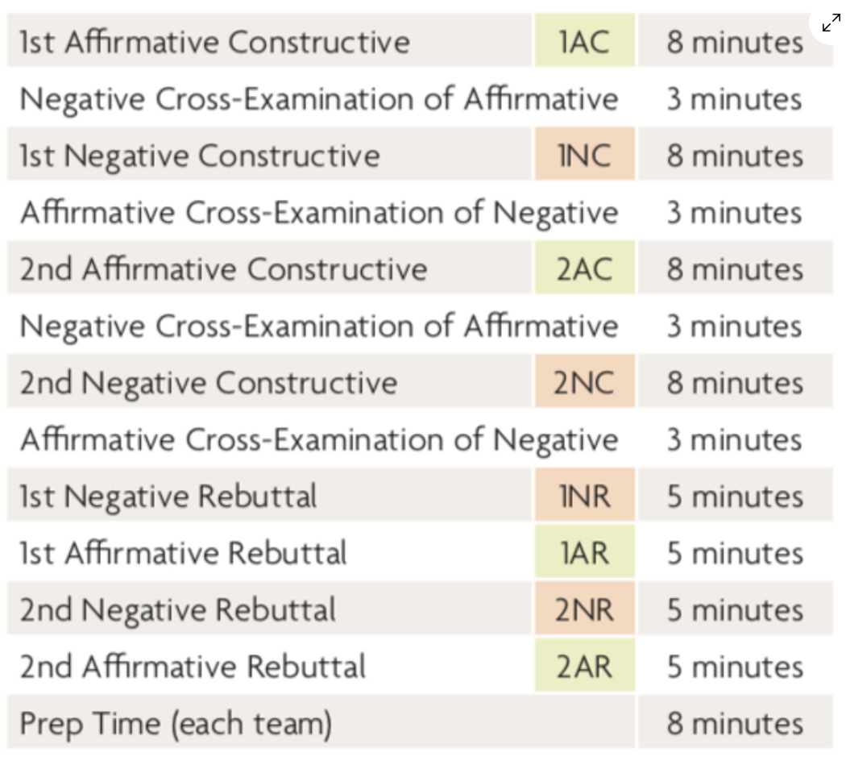  Assigning Speaker Points  In addition to choosing the winner of each debate, judges also award “speaker points” to assess the quality of the presentation offered by each debater. This is entirely separate from who won the debate. Usually the side that wins the debate also receives higher speaker points, however, you might award more speaker points to the loser of the debate if they generally spoke better but failed to address an important argument or committed some fatal flaw of logic. Please consider the following factors when awarding speaker points:  - Does the speaker present in a fluent and compelling manner?  - Does the speaker use all available speech time and cross examination time?  - Does the speaker properly reference opposing arguments and cite allusions to evidence?  - Does the speaker address the opponent in an appropriate style (i.e., not demeaning)?  - Does the speaker stay on topic?  Speaker Points Guide  30 - You are one of the best speakers I have ever heard! Like wow, you should be a professional.  28-29 - Amazing job! You were nearly flawless in your delivery with only a couple of stumbles.  26-27 - Solid speeches, but could use a little work.  24-25 - Decent effort, but there were some stumbles  22-23 - Good effort, but there were major stumbles  20-21 - Debater was rude, offensive, or inappropriate.  < 20 - Do NOT assign speaker points this low without first talking to tab.
How do I flow?

You're going to need:  - 2 pens of different colors  - a stack of legal sized paper  - highlighters (this is optional) | Tips  - Use a different piece of paper for each argument.  - Write what’s said in each speech in the respective column.  - Flow what both teams say about a specific argument next to each other.  - Flow the tags (assertions and reasoning), author’s last name, and year of publication.  - Leave space between arguments in case the other team had multiple answers to the same argument.  - Write quickly by abbreviating or using symbols. examples below.

Abbreviations & Symbols
Generic |  | Debate |  | Topic
⍉ | Don’t, doesn’t, won’t, not | Uq | Uniqueness | © | Copyright
⦻ | Wreaks,destroys, kills, undermines | L | Link | ™ | Trademark
→ | Leads to | I | Impact | P | Patent
↑↓ | Increase, decrease | nu | Non-unique
Δ | Change | IL | Internal Link
b/c | Because | cp | Counterplan
 |  | K | Kritik (critique)

Example Flow
1AC  Dogs = good pets b/c they protect | 1NC  Dogs ≠ good pets  - b/c they bite  - b/c they are expensive | 2AC  Dogs = good b/c protect  1A. Biting = defense  1B. Training ↓ # bites  2. Save $ by keeping safe | 2NC/1NR  Dogs ≠ good b/c $  2A. Costs more $ to feed them  2B. Vet = $500/visit | 1AR  Dogs = good b/c protect  - Neg drop bites=protect  2B. Only go to vet 2x/yr | 2NR  Dogs ≠ good b/c $  Vote neg b/c saving $ = good  2A. Aff concedes feeding = more $ than protect worth | 2AR  Dogs = good b/c protect  Vote aff b/c safety > $  - Bites → safety & training → protection  2B. Concede vet =2x/yr so ≠ expensive

Policy Vocabulary
Alternative: In critiques/kritiks, the negative’s proposed different way(s) of addressing the issue raised by the affirmative.
Conditionality: Arguments that are advanced under certain conditions and may be dropped if proven undesirable.
Counterplan: An alternative plan proposed by the negative.
Fiat: The assumption that the plan is adopted for the purpose of testing its merits.
Inherency: The affirmative must prove their plan is not being implemented in the status quo.
Kritik (pronounced critique): A philosophical criticism of what is being advocated.
Non-topical: If the affirmative plan does not fit within the bounds of the resolution.
Paradigm: A judge’s way of seeing the debate, such as stock issues or policy-making.
Permutation (perm): A combination of the plan and all or part of the counterplan or kritik alternative.
Plan Inclusive Counterplan (PIC): A counterplan that does part of the affirmative plan but not all of it.
Road map: The identification of the order you will address the major positions in the debate.
Sign posting: Referring to where you are on the flow and what you are answering so the judge can follow.
Spread: Talking as quickly as possible in a debate.
Uniqueness: The argument that the status quo is stable or changing in a way relevant to the plan or counterplan.

