**WACFL judge instructions for Lincoln-Douglas debate**

September/October 2024 topic:

**Resolved: The United States ought to require that workers receive a living wage.**

**Timing and sequence of speeches**

* Affirmative Constructive: 6 minutes
* Cross Examination: 3 minutes. Negative speaker asks questions of the affirmative.
* Negative Constructive/Rebuttal: 7 minutes
* Cross Examination: 3 minutes. Affirmative speaker asks questions of the negative.
* Affirmative Rebuttal: 4 minutes
* Negative Rebuttal: 6 minutes
* Affirmative Rebuttal: 3 minutes

A LD debate round lasts approximately 45 minutes. Affirmative debaters support the resolution. Negative debaters reject the resolution. Although each debater has 13 minutes of speaking time, the Affirmative has 3 shorter speaking blocks and the Negative has 2 longer blocks. Each debater is allowed 4 minutes preparation time for the round. Judges keep time, so they know when a debater has reached their time limit. The judge should call time when the limit is reached.

**Tournament schedule**

* Round 1: 9:00 am
* Round 2: 11:00 am
* Lunch break
* Round 3: 1:15 pm
* Round 4: 3:00 pm

When you receive your assignment (via text and/or email), proceed quickly to the classroom. When you arrive, sit in the back of the room and on your laptop, go to Tabroom.com. Click on your email address at the top right corner, find the button that says **Current Ballots and Panels**. When both debaters have arrived, click the green **START ROUND** button. This action will activate your ballot for the round.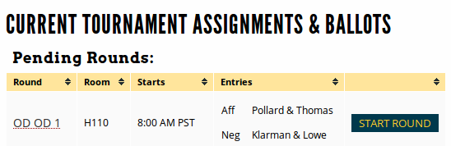

**The judge’s role during the debate round**

* Take notes and listen actively to the students. Even though you may have personal opinions on the topic, you should only evaluate arguments that the students present.
* Keep time. Generally, students will time themselves, but to ensure students do not run over their allotted time, the judges should also keep time. When a student reaches their limit, you should clearly (but politely) tell them they have reached their limit. Judges must also keep track of prep time.
* Do not provide verbal feedback, either during or after the round. When the round is finished, students should not know how you are voting.

**When the debate is finished, you have 2 tasks.**

1. Choose a winner and assign points to each debater. As soon as possible, submit your decision and speaker points. The point range is as follows: Outstanding = 27-30; Above Average = 25-27; Average = 22-25; Below Average = 18-22. The winning debater should always receive higher points. When you have made your decision, click the **Submit Ballot** button. Please do this soon ASAP after the round ends.

After submission, you must confirm your ballot. You'll be shown your decision and points, with the option to re-enter or confirm. This message looks alarming, but if your decision and points are accurate, just push **Yes! Correct! Confirm it.**

1. Provide feedback to both debaters. The ballot has three different tabs where you can write comments:
   * Reason for Decision (RFD): These comments go to both debaters and their coach. This explains why you voted for one over the other. This is the most important feedback for the students.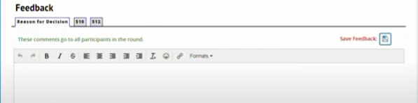
   * Feedback for Affirmative. This is only visible to the Affirmative debater and their coach. The Negative debater will not see them.
   * Feedback for Negative). This is only visible to the Negative debater and their coach. The Affirmative debater will not see them.

You will see a button at the top right labeled “Save Feedback.” It saves your work, but does not finalize the comments. Your decision and speaker points need to be submitted soon after the round ends. However, the comments sections for all your rounds will remain open for at least 30 minutes after the last round of the day has finished. Just click on **Edit Comments** to revise your feedback during the day.

**Suppose there is an issue in the round?** There are several reasons you’d need to contact tournament officials. Sometimes judges have technical issues with their laptop or Tabroom.com. If a student does not arrive for their assigned round, judges cannot call a forfeit. That is the decision for WACFL tournament officials to make.

If you have an issue you can’t solve, you can email **tabroom@wacfl.org** or text **703-239-4576**. Be sure to identify yourself and the room you are in, along with the issue. Please do not call. This number is monitored only for texts.

**Suppose I’m not assigned a round to judge?** Please remain in the Judges Lounge for approx. 20 minutes after rounds are sent. Often, we need people to fill in for missing judges.

**Help students straighten up the classroom after each round**. We are guests at the host school. Before you leave the classroom, please ask students to help you arrange chairs and get the room back to its original configuration. On Monday, teachers should find desks and chairs where they left them on Friday.

**Please consider judging at the next WACFL tournament.** For most coaches, their toughest challenge is finding adults willing to judge. We’d love to have you join us again! Please talk with your team’s coach about volunteering for next month’s tournament.

**Guidance for Assigning Speaker Points**