**WACFL judge instructions for Public Forum debate**

September / October 2024 topic:

**Resolved: The United States federal government should substantially expand its surveillance infrastructure along its southern border.**

**Timing and sequence of speeches**

* First Pro Constructive: 4 minutes.
* First Con Constructive: 4 minutes.
* Crossfire: 3 minutes. The 1st Con asks the first question. Then either 1st debater may ask questions.
* Second Pro Constructive: 4 minutes.
* Second Con Constructive: 4 minutes.
* Crossfire: 3 minutes. The 2nd Pro asks the first question. Then either 2nd debater may ask questions.
* First Pro Summary: 3 minutes
* First Con Summary: 3 minutes
* Grand Crossfire: 3 minutes. One member of the Pro team asks the first question. Then any debater may ask questions.
* Second Pro Final Focus: 2 minutes
* Second Con Final Focus: 2 minutes

A PF debate round lasts approximately 45 minutes. PRO debaters support the resolution. CON debaters reject the resolution. Each team is allowed 3 minutes preparation time for the round. Judges keep time, so they know when a team has reached their limit. The judge should call time when the limit is reached.

**Tournament schedule**

WACFL preliminary tournaments are “double-flighted.” This means each of the four rounds actually consists of two debates, an “flight1” and a “flight 2.” The flight 1 teams should go first. However, the flight 2 teams may start first if a flight 1 competitor is missing. This avoids delays and forfeits. Do not mix debaters from different flights.

* Round 1: 9:00 am
* Round 2: 10:45 am
* Lunch break
* Round 3: 1:00 pm
* Round 4: 3:00 pm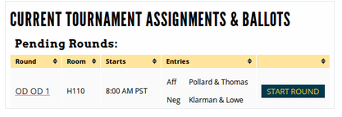

When you receive your assignment (via text and/or email), proceed quickly to the classroom. When you arrive, sit in the back of the room and on your laptop, go to Tabroom.com. Click on your email address at the top right corner, find the button that says **Current Ballots and Panels**. When both teams have arrived (4 debaters), click the green **START ROUND** button. This action will activate your ballot for the round.

**The judge’s role during the debate round**

* Take notes and listen actively to the students. Even though you may have personal opinions on the topic, you should only evaluate arguments that the students present.
* Keep time. Generally, students will time themselves, but to ensure students do not run over their allotted time, judges must keep time. When a student reaches their limit, you should clearly (but politely) tell them they have reached their limit. Judges must also keep track of prep time.
* Do not provide verbal feedback, either during or after the round. When the round is finished, students should not know how you are voting.

**When the debate is finished, you have 2 tasks.**

1. Choose a winner and assign points to each team. As soon as possible, submit your decision and speaker points. The point range is as follows: Outstanding = 27-30; Above Average = 25-27; Average = 22-25; Below Average = 18-22. The winning team should always receive higher points. When you have made your decision, click the **Submit Ballot** button. Please do this ASAP after the round ends.

After submission, you must confirm your decision. You'll be shown your decision and points, with the option to re-enter or confirm. This message looks alarming, but if your decision and points are accurate, just push **Yes! Correct! Confirm it.**

1. Provide feedback to both teams. The ballot has three different tabs where you can write comments:
   * Reason for Decision (RFD): These comments go to all debaters and their coach. This explains why you voted for one team over the other. This is the most important feedback for the students.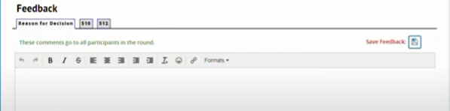
   * Feedback for PRO. This is only visible to the PRO team and their coach. The CON team will not see this.
   * Feedback for CON. This is only visible to the CON team and their coach. The PRO team will not see this.

You will see a button at the top right labeled “**Save Feedback**.” It saves your work, but doesn’t finalize the comments. Your decision and speaker points must be submitted as soon as possible after the round ends. However, the comments sections for all your rounds will remain open for at least 30 minutes after the last debate of the day has ended. Just click on **Edit Comments** to revise your feedback during the day.

**Suppose there is an issue in the round?**

There are several reasons you’d need to contact tournament officials. Perhaps you have a technical issue with your laptop or accessing Tabroom.com. Sometimes a student does not arrive for their assigned round. Judges cannot call a forfeit. That is a decision for WACFL tournament officials to make.

If you have an issue you can’t solve, you can email **tabroom@wacfl.org** or text **703-239-4576**. Be sure to identify yourself and the room you are in, along with the issue. Please do not call. This number is monitored only for texts.

**Suppose I’m not assigned a round to judge?**

Please remain in the Judges Lounge for approx. 20 minutes after rounds are sent. We often need people to fill in for missing judges.

**Help students straighten up the classroom after each round**. We are guests at the host school. Before you leave the classroom, please ask students to help you arrange chairs and get the room back to its original configuration. On Monday, teachers should find desks and chairs where they left them on Friday.

**Please consider judging at the next WACFL tournament.** For most coaches, their toughest challenge is finding adults willing to judge. We’d love to have you join us again! Please talk with your team’s coach about volunteering for next month’s tournament.

**Guidance for Assigning Speaker Points**